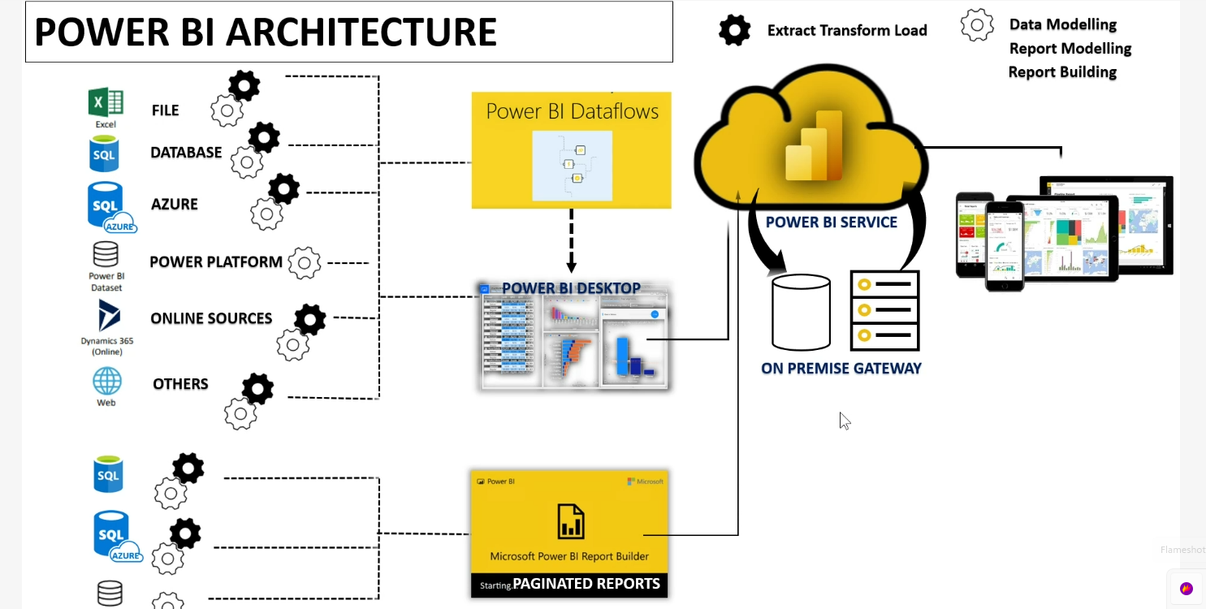

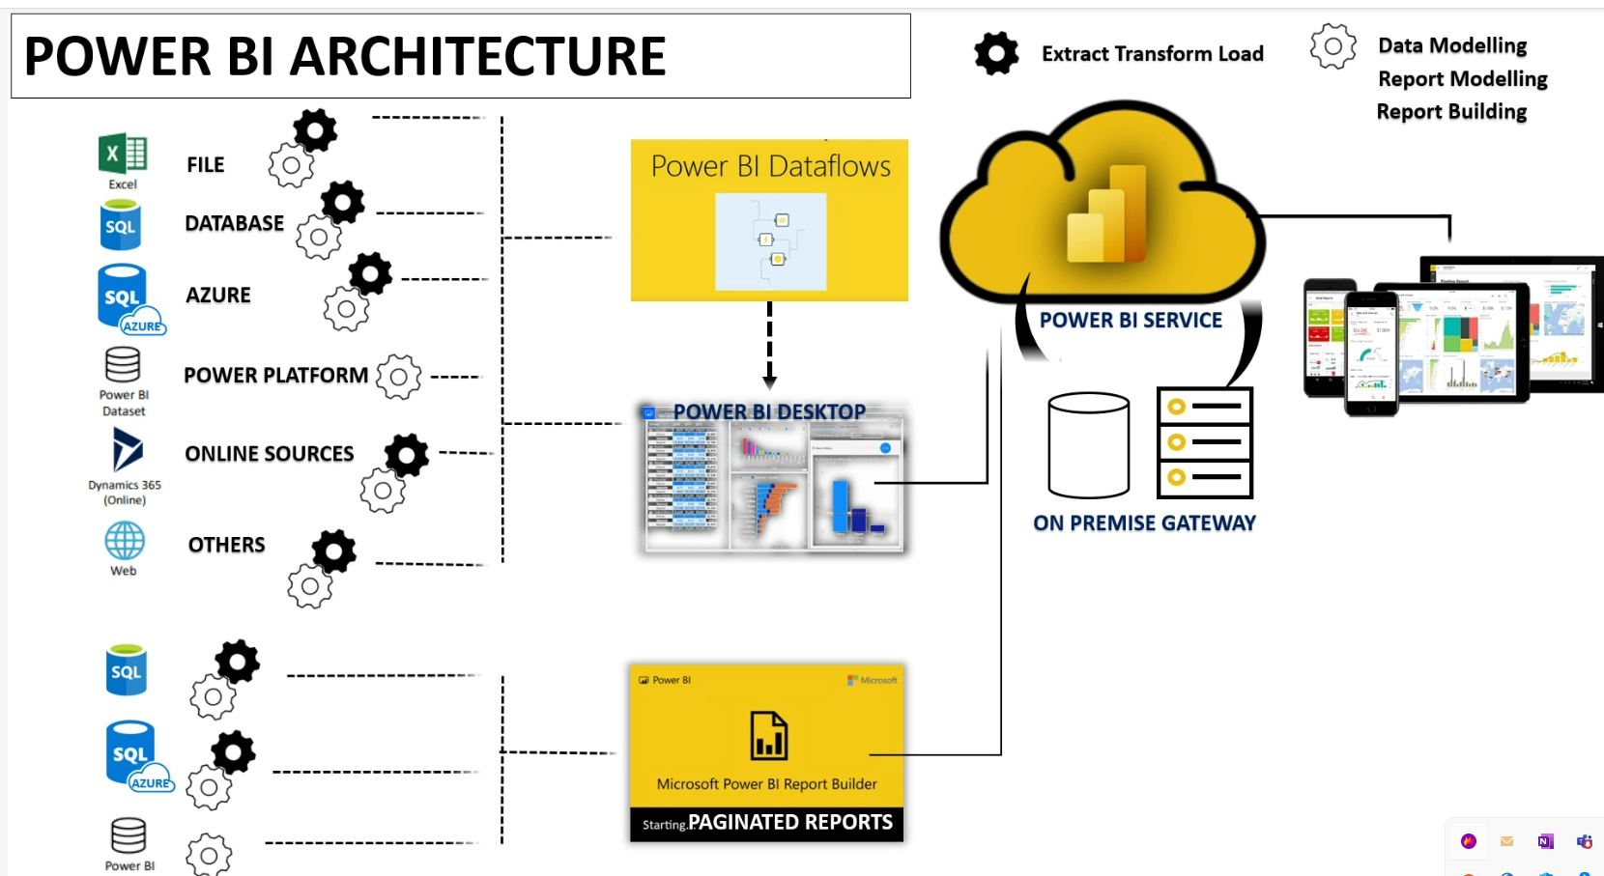

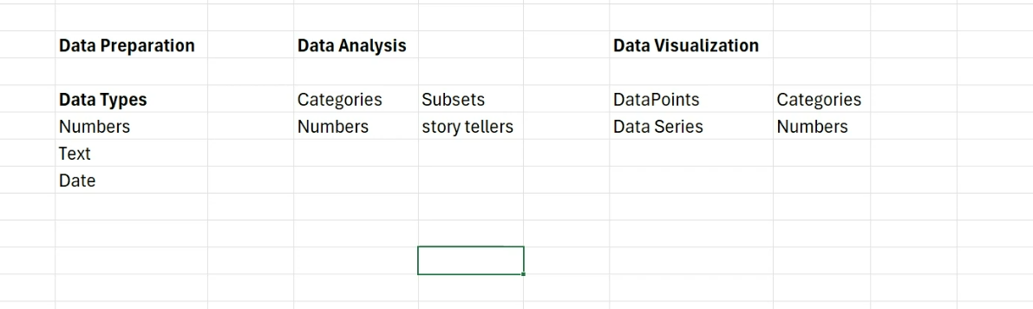

Sorting technique for text field, eg (Months)

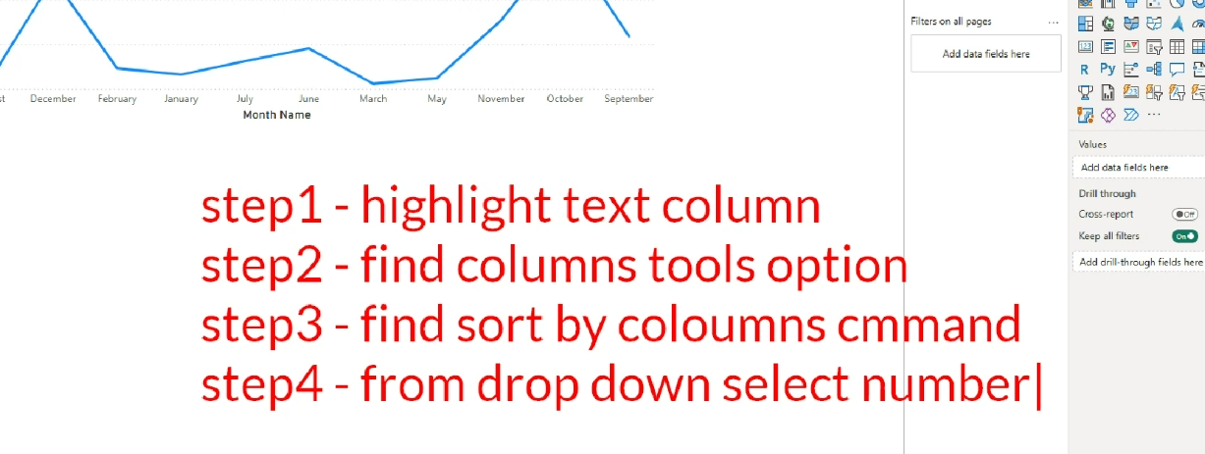

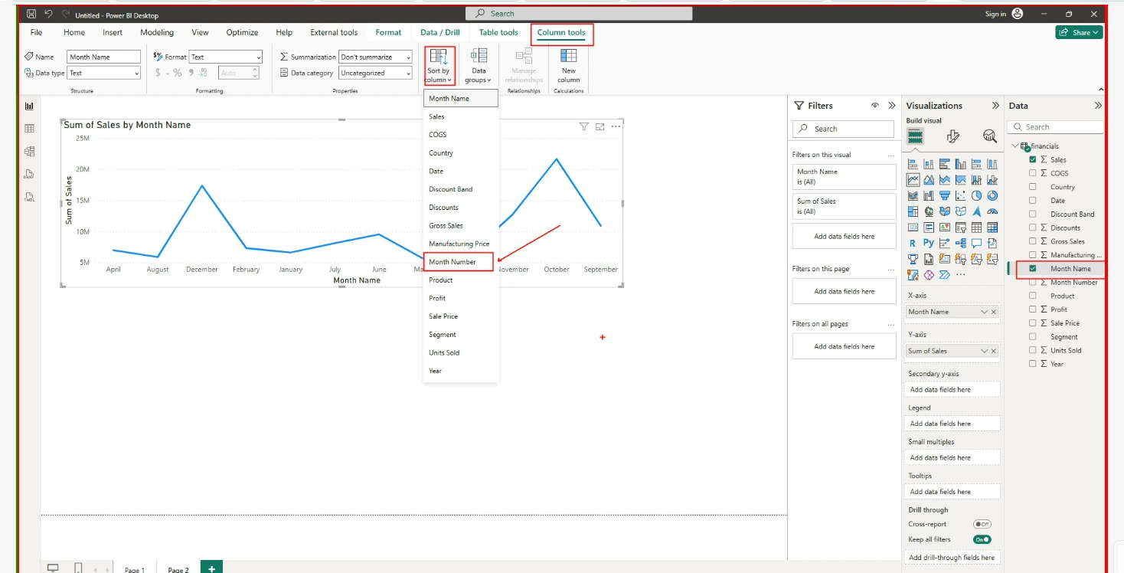

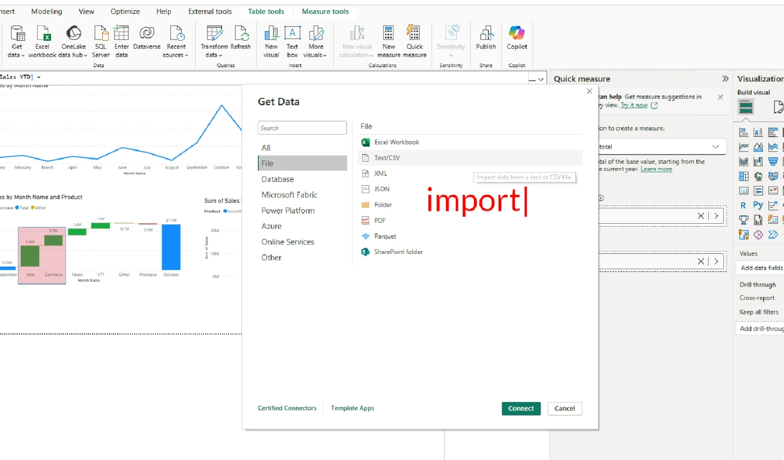

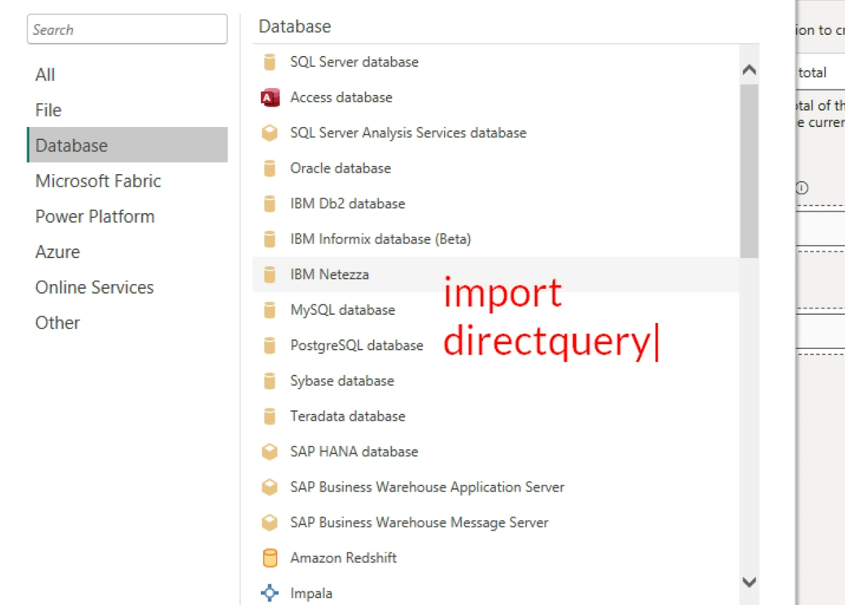

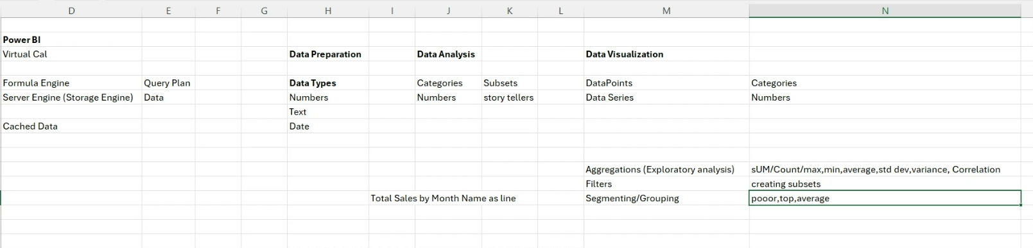

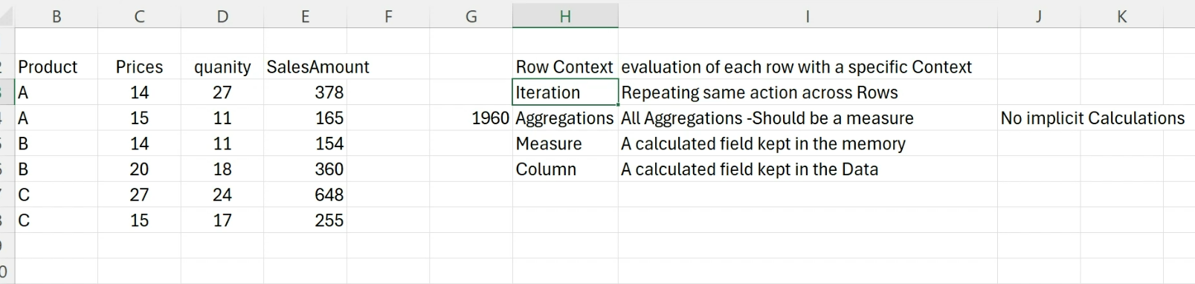

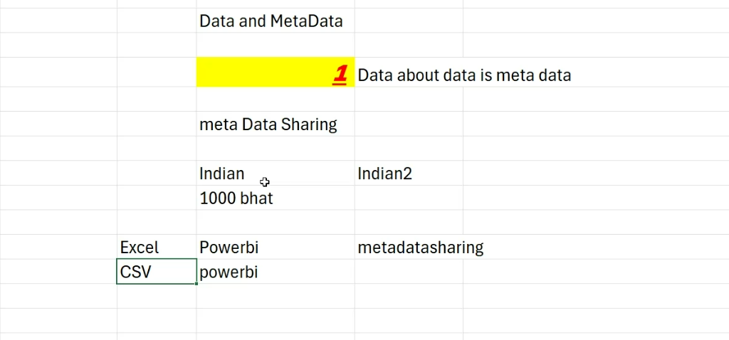

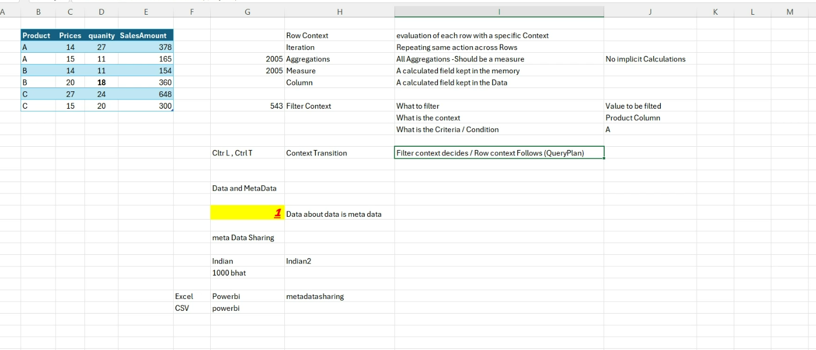

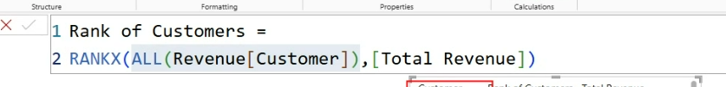

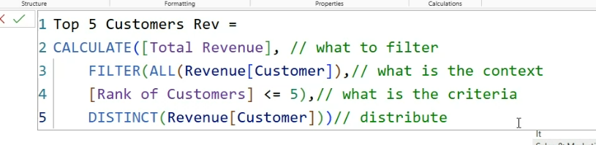

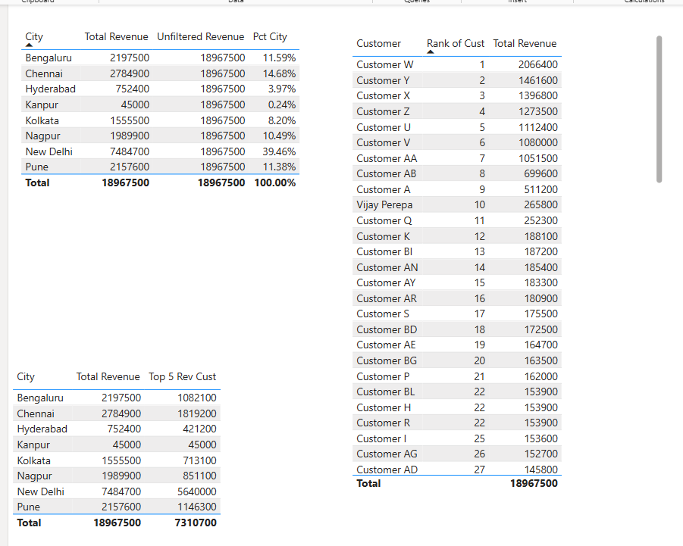

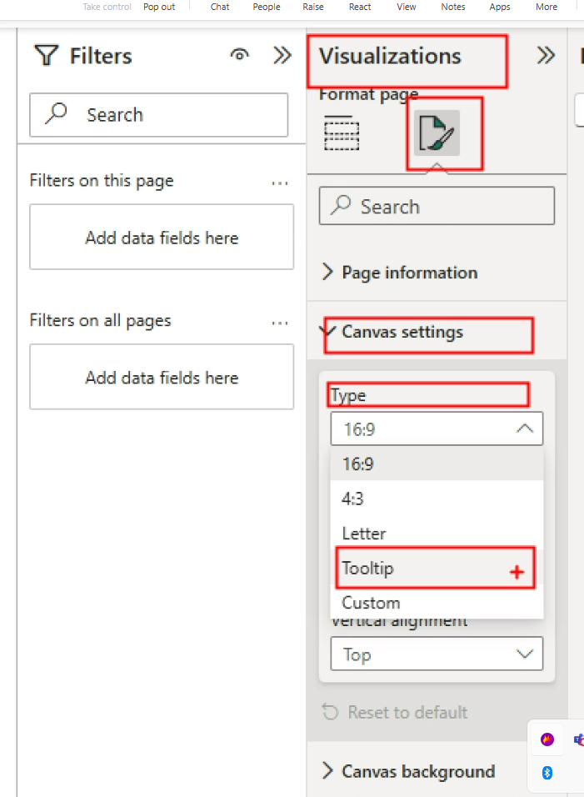

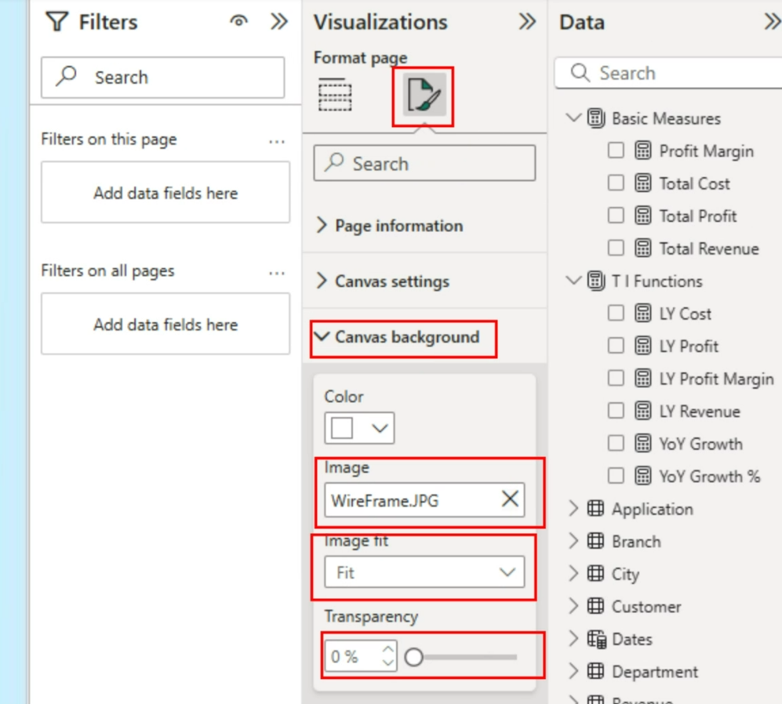

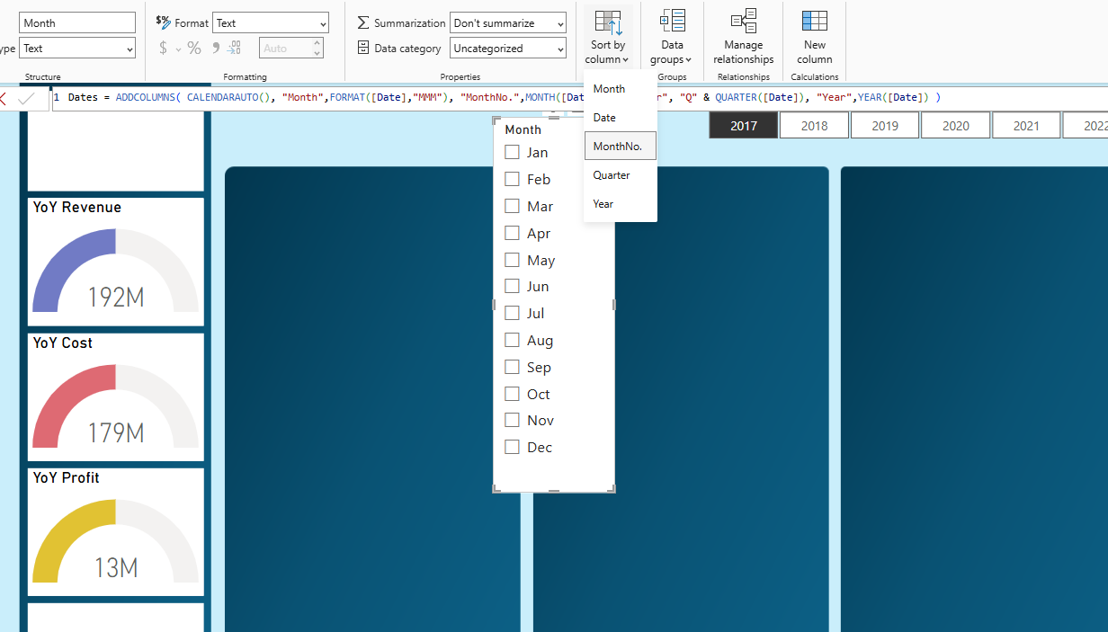

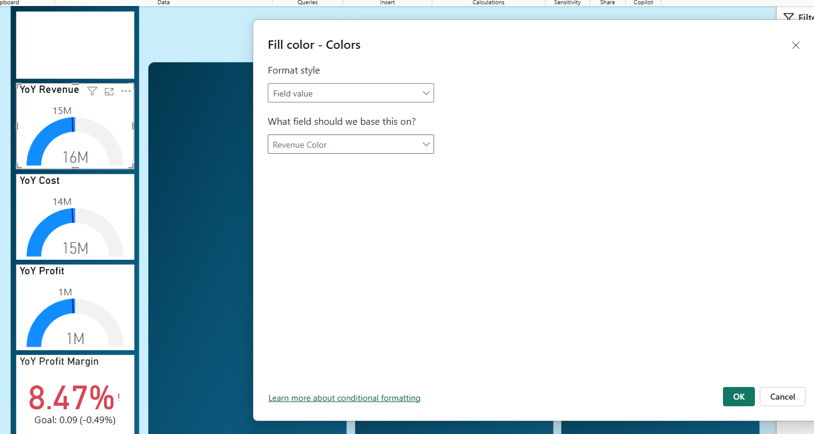

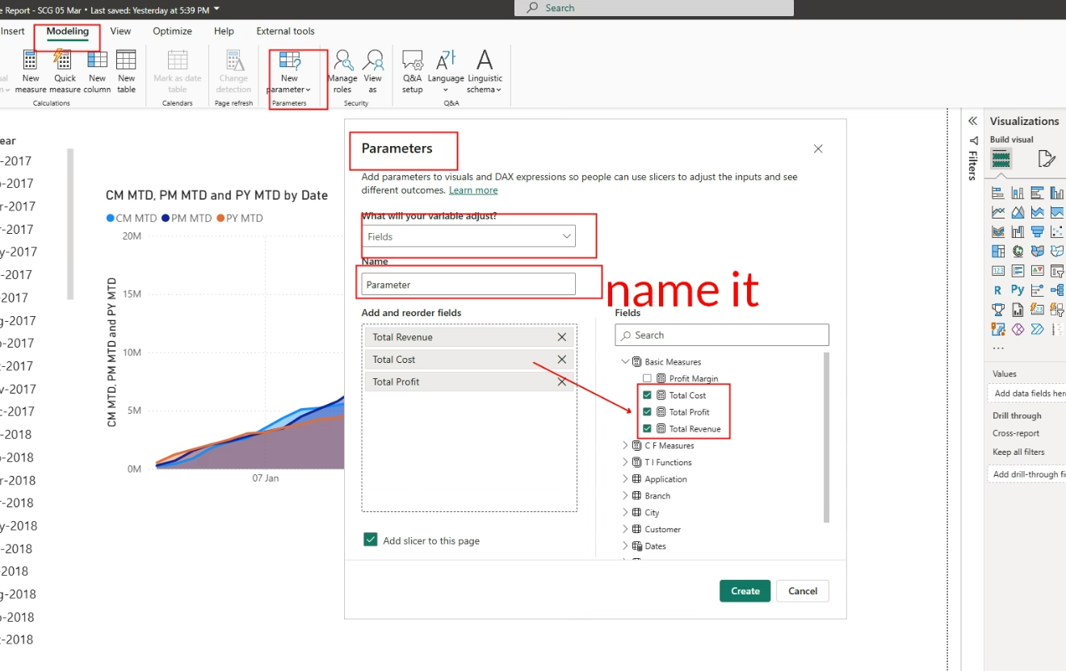

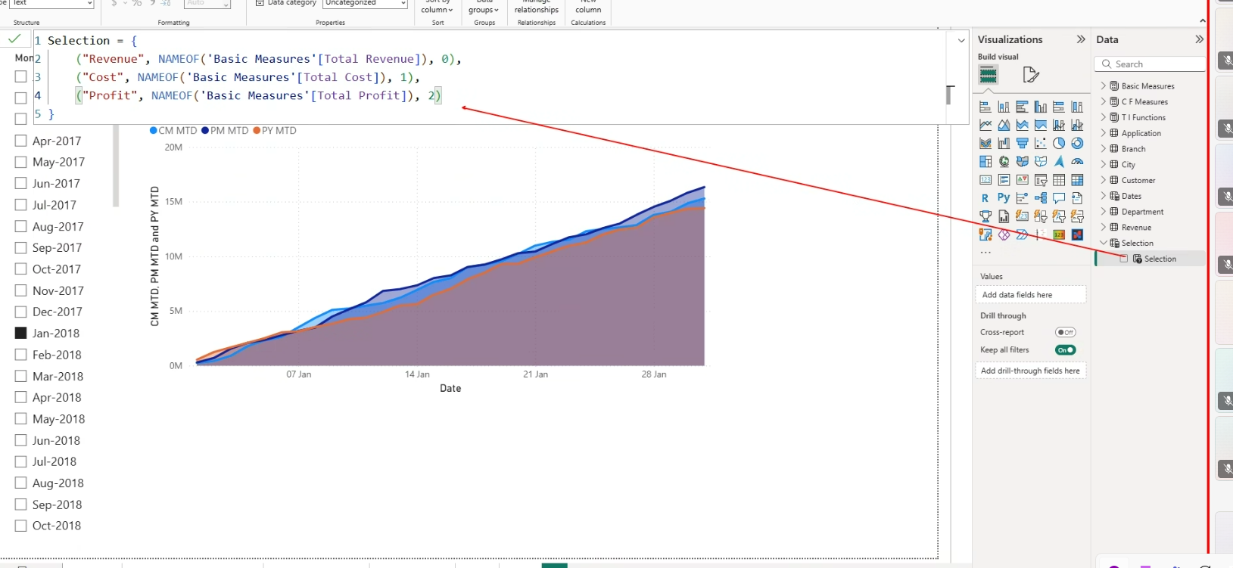

**Bookmarking:**

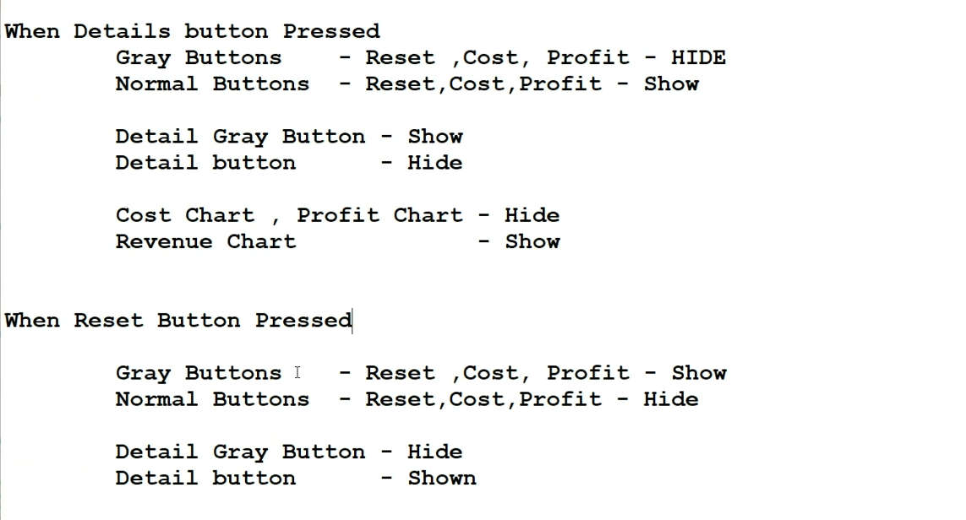

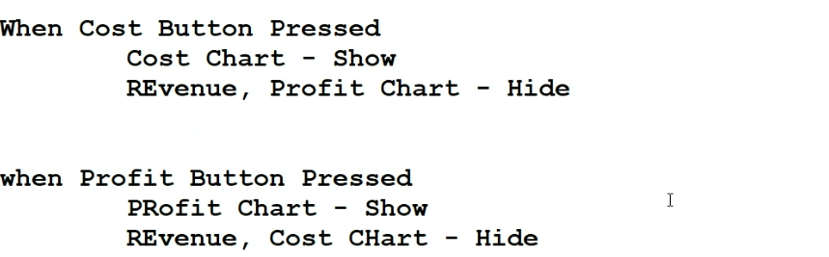

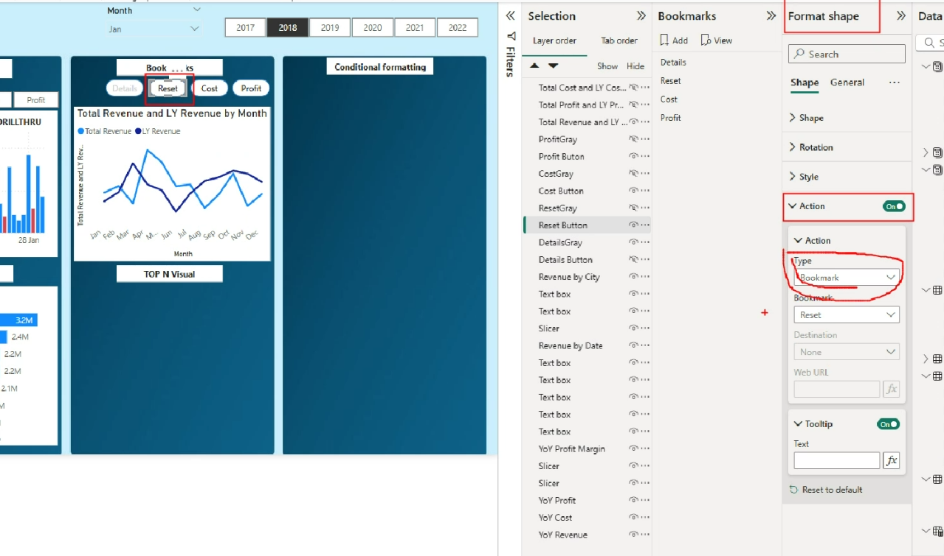

**Conditional Formatting**

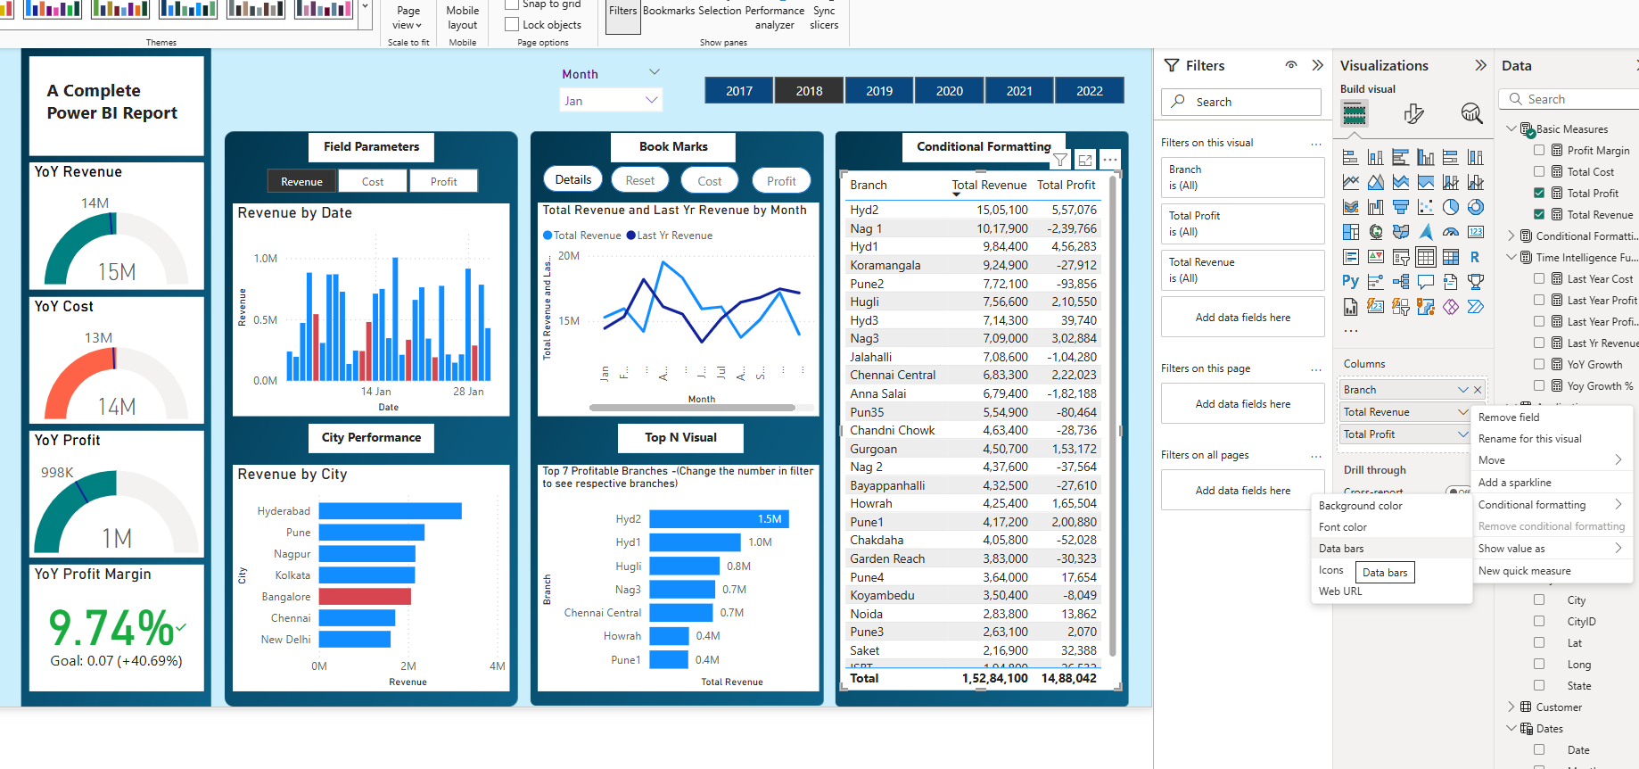

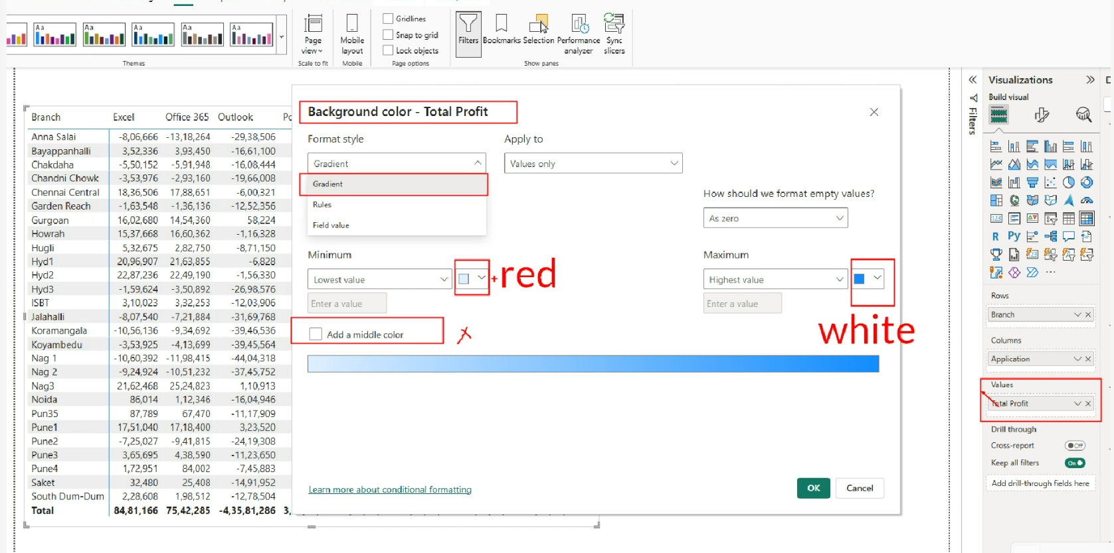

**Conditional Formatting based on another value**

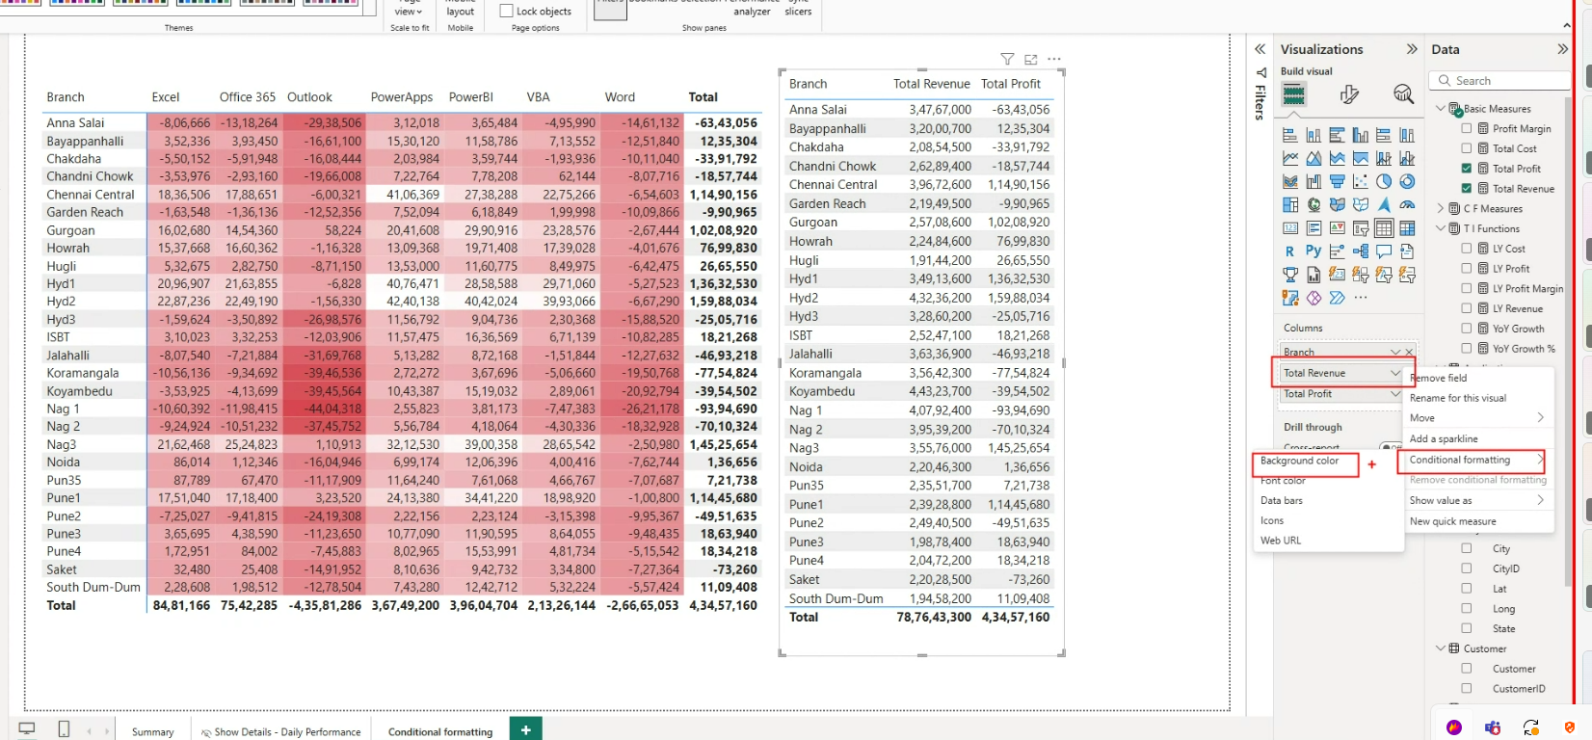

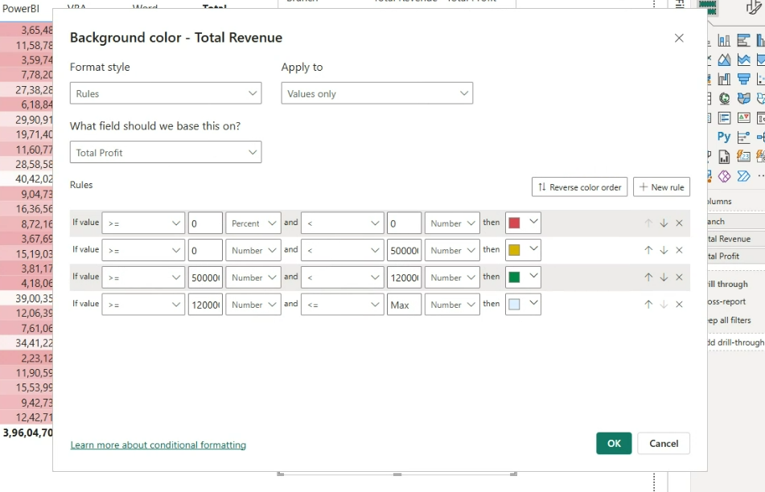

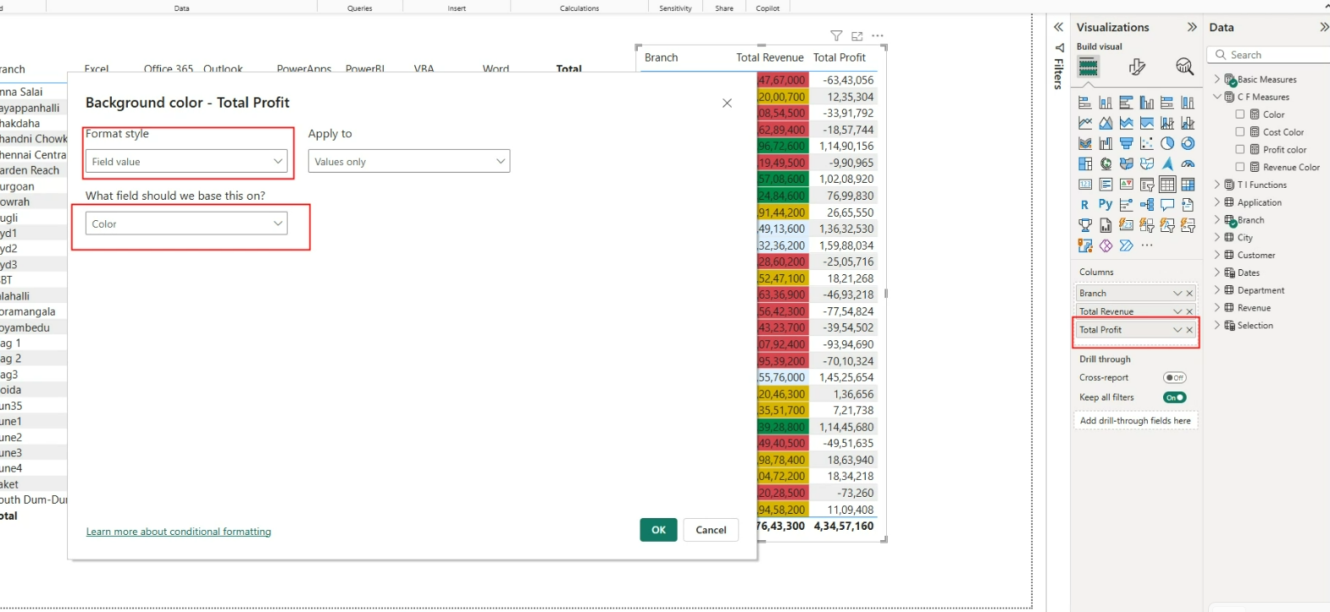

**Time Intelligence**

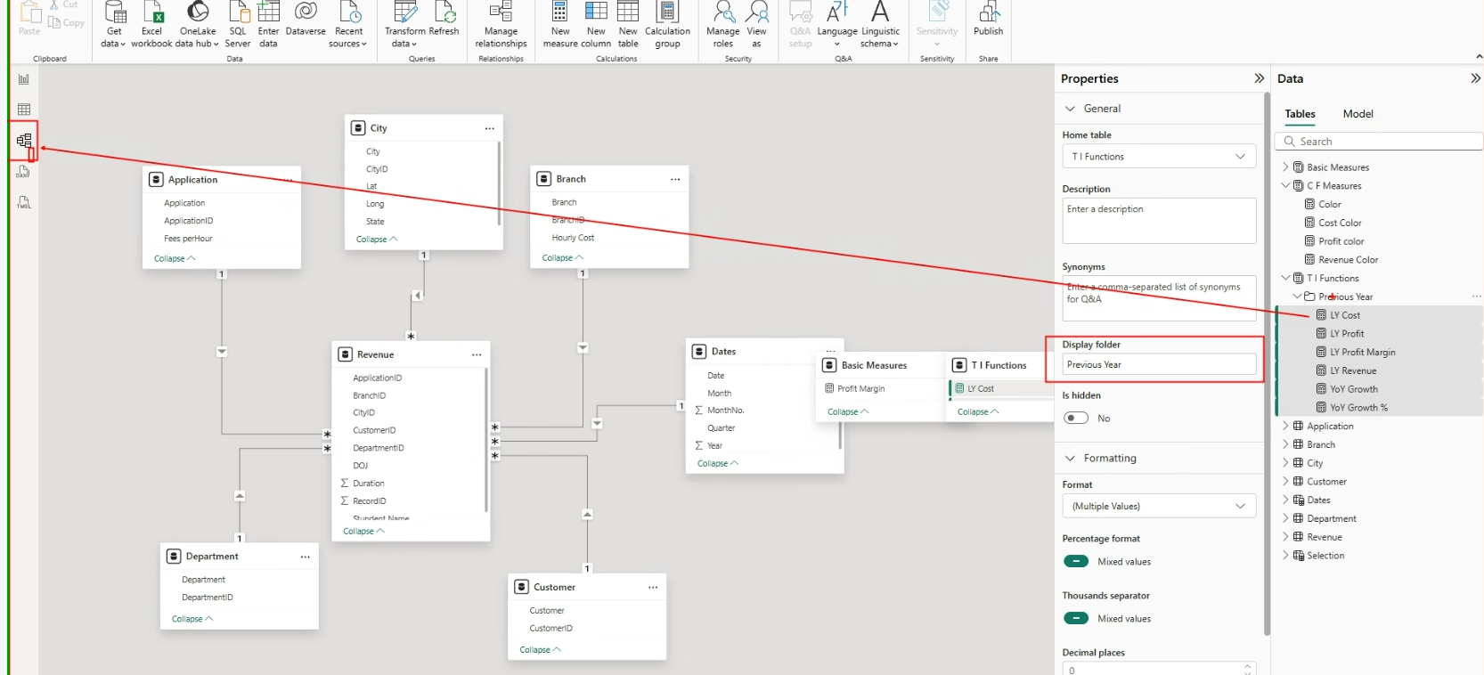

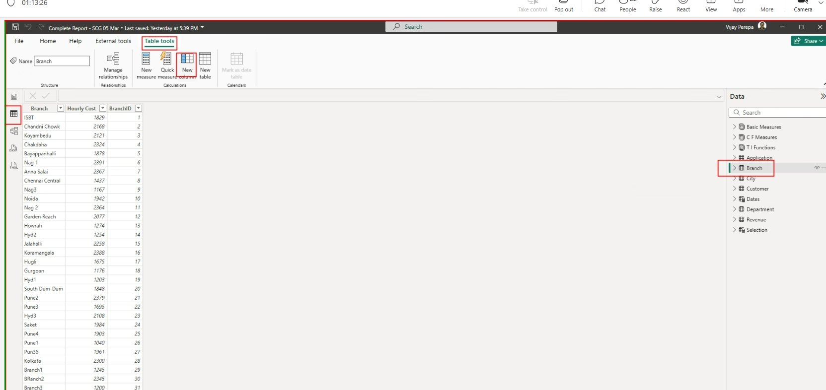

**Cumulative**

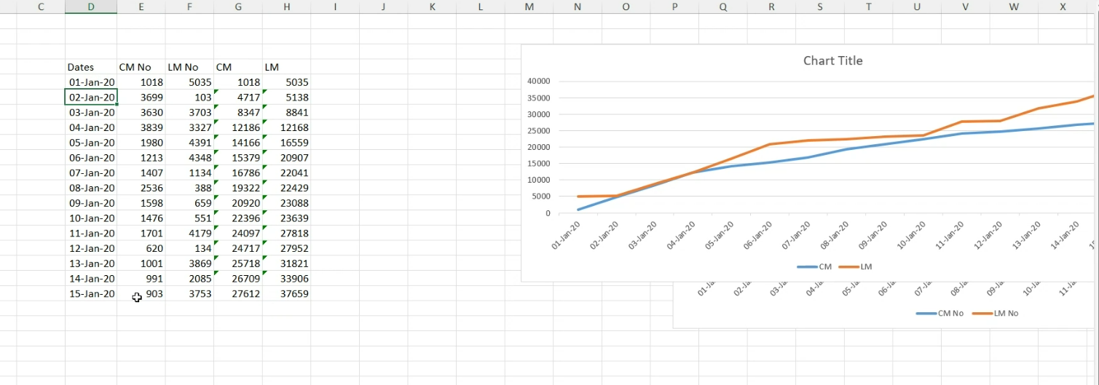

**AGEING ANALYSIS**

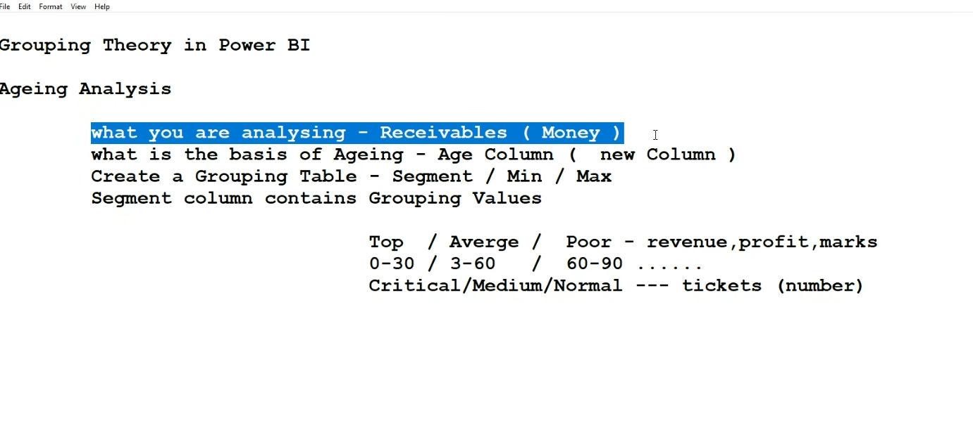

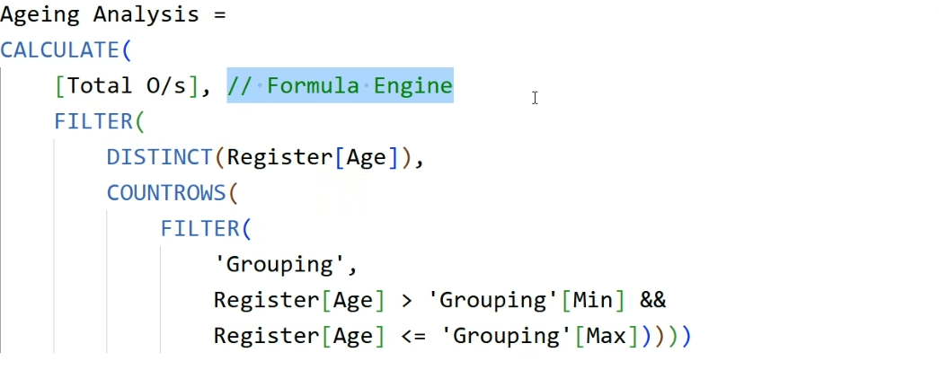

Ageing Analysis =

CALCULATE(

    [Total Receivables],

    FILTER(

        DISTINCT(Register[Age]),

        COUNTROWS(

            FILTER(

                'Grouping',

                Register[Age] >  'Grouping'[Min] &&

                Register[Age] <= 'Grouping'[Max]))))

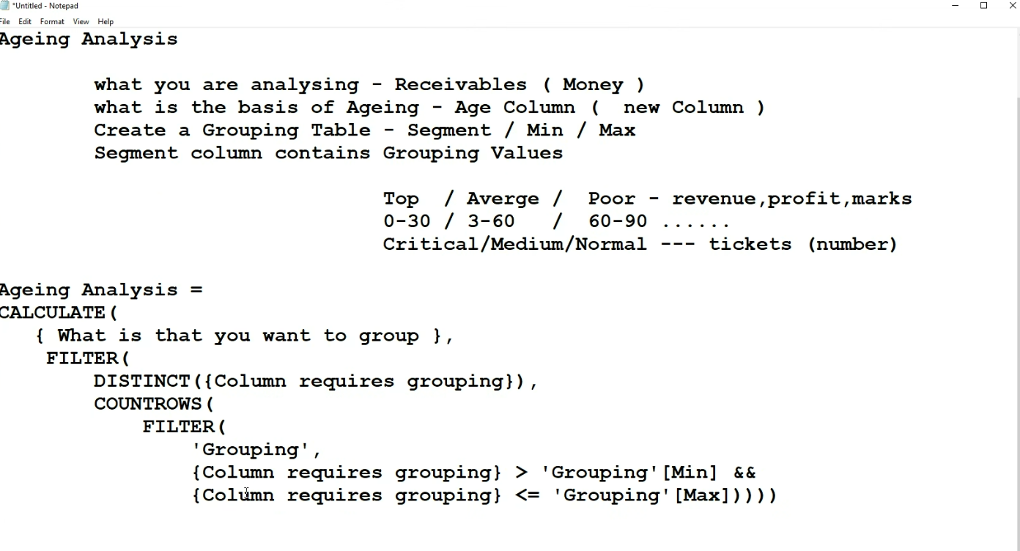

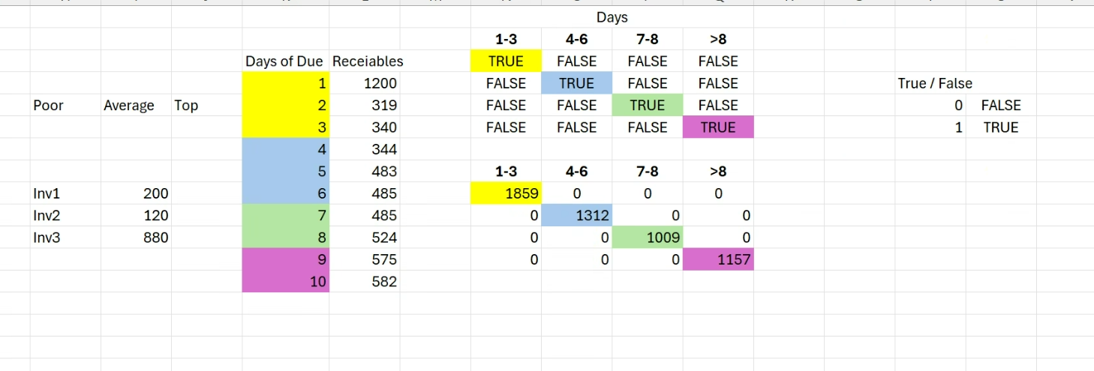

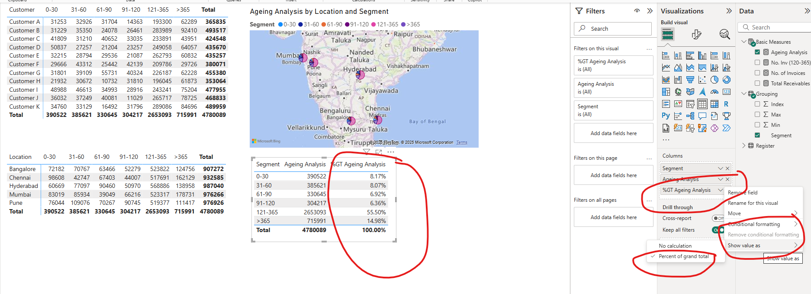

**Q&A Setup**

**6/3/25- New Report**

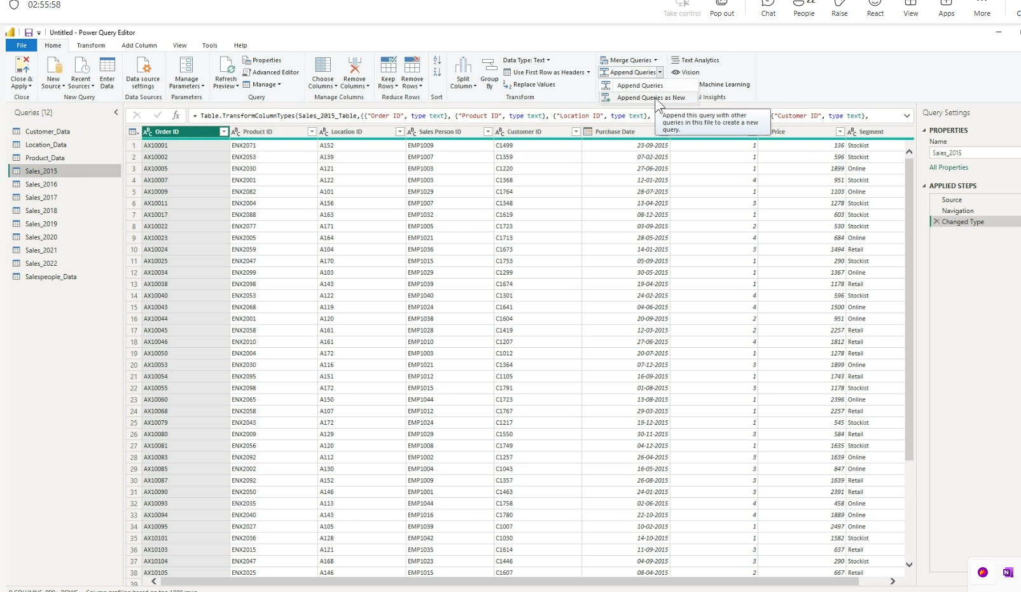

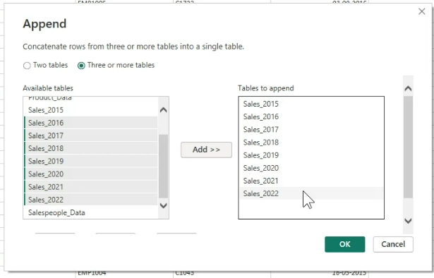

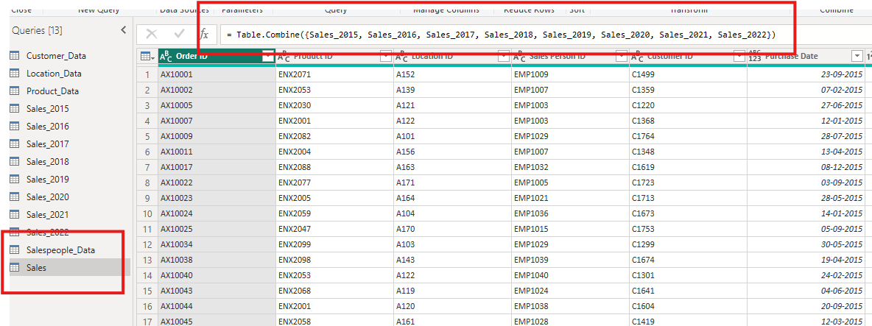

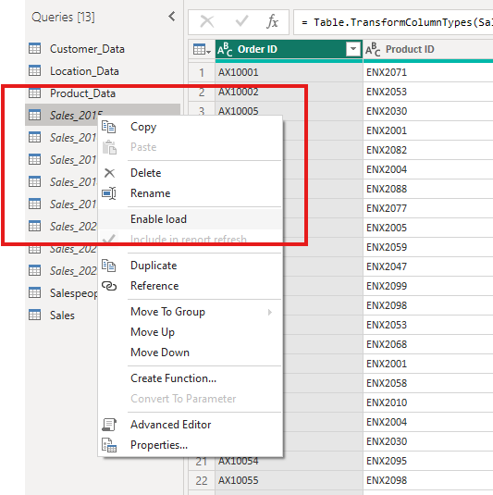

Dates = ADDCOLUMNS( CALENDARAUTO (),

        "Month",    FORMAT([Date],"MMM"),

        "MonthNo.", MONTH([Date]),

        "Quarter","Q" & QUARTER([Date]),

        "Year",YEAR([Date]),

        "MonthYear",FORMAT([Date],"MMM")& "-" & YEAR([Date]),

        "MonthYearSor",YEAR([Date])*100 + MONTH([Date]),

        "Quarter Year", "Q" &QUARTER([Date]) & "-" & YEAR([Date]),

        "Quarter Year Sort",YEAR([Date]) * 100 + QUARTER([Date]))

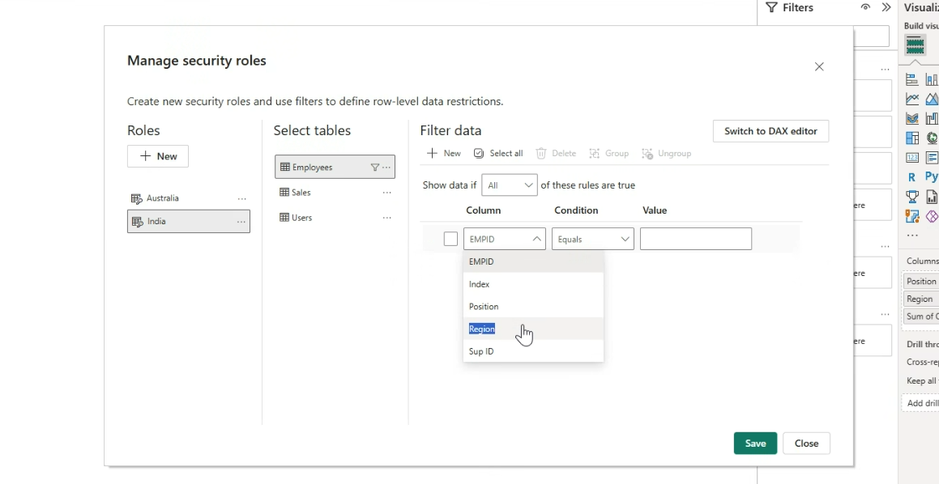

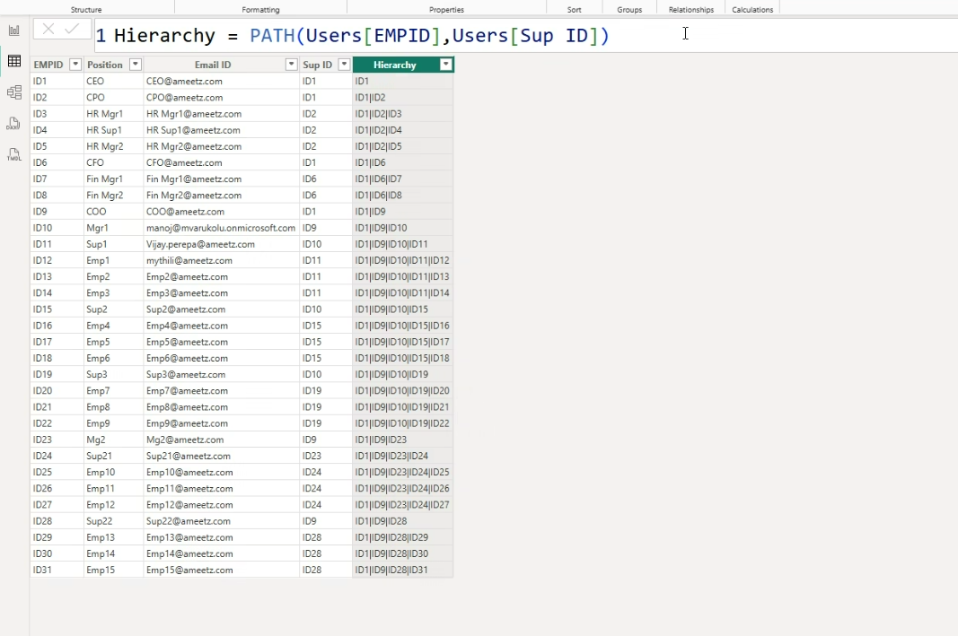

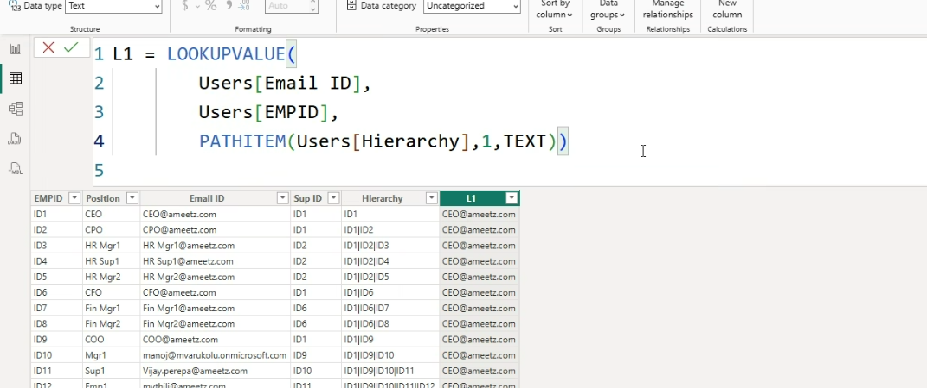

**GithubLinks:**

[**https://github.com/VijayPerepa/LDRA/blob/main/Dynamic%20Relation%20Ship%20(1).xlsx**](https://github.com/VijayPerepa/LDRA/blob/main/Dynamic%20Relation%20Ship%20(1).xlsx)

[**https://github.com/VijayPerepa/LDRA/blob/main/04%20MAR%20SCG%20-%20Project%201%20(Tooltip)%20.pbix**](https://github.com/VijayPerepa/LDRA/blob/main/04%20MAR%20SCG%20-%20Project%201%20(Tooltip)%20.pbix)

[**https://github.com/VijayPerepa/LDRA/blob/main/PowerBi%20Dashboard%20Avanced%20(1).xlsx**](https://github.com/VijayPerepa/LDRA/blob/main/PowerBi%20Dashboard%20Avanced%20(1).xlsx)

[**https://github.com/VijayPerepa/LDRA/blob/main/MultiDimensionData%20(2).xlsx**](https://github.com/VijayPerepa/LDRA/blob/main/MultiDimensionData%20(2).xlsx)

[**https://github.com/VijayPerepa/LDRA/blob/main/Dynamic%20Relation%20Ship%20(1).xlsx**](https://github.com/VijayPerepa/LDRA/blob/main/Dynamic%20Relation%20Ship%20(1).xlsx)

**Youtube:**

[**https://www.youtube.com/watch?v=hamC5sYfsH8&list=PLWQB3PEUJKRn1Y_s8whVWEoPPZa6Wm8B6&index=4&pp=gAQBiAQB**](https://www.youtube.com/watch?v=hamC5sYfsH8&list=PLWQB3PEUJKRn1Y_s8whVWEoPPZa6Wm8B6&index=4&pp=gAQBiAQB)

**HR Recruitment Tracker (Analysis) Part 1 Dataset Creation**

**HR Recruitment Analysis Part 2 Data Modelling, DAX, Report Preparation in Power BI**

**Assignment:**

[**https://github.com/VijayPerepa/LDRA/blob/main/Business%20Analysis.xlsx**](https://github.com/VijayPerepa/LDRA/blob/main/Business%20Analysis.xlsx)

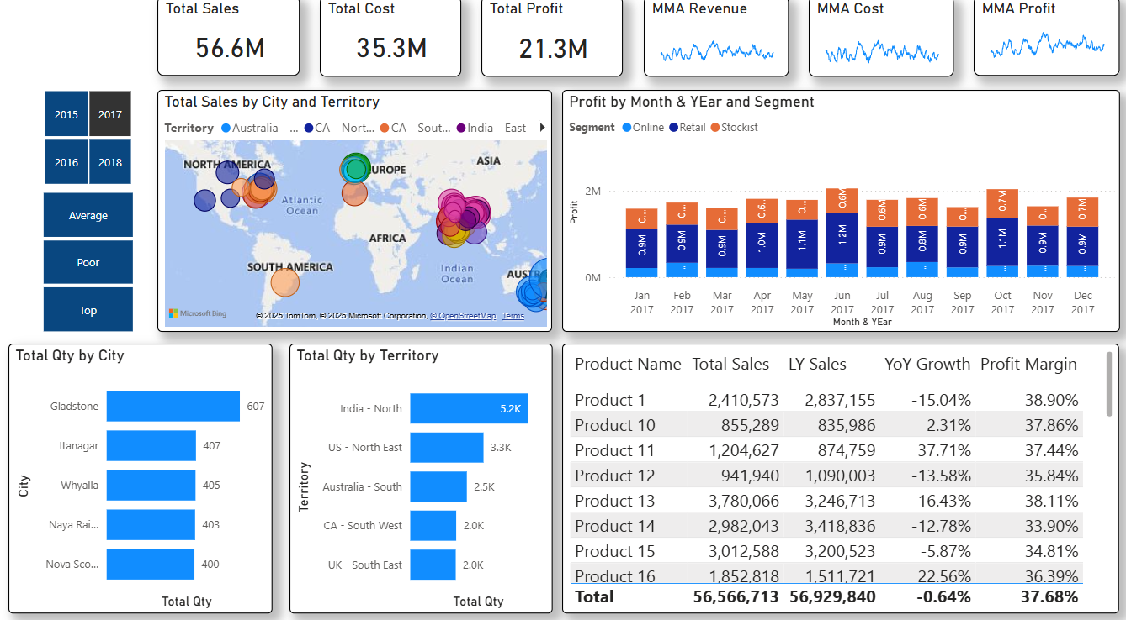

**Linked IN**

**linkedin.com/in/vijayperepa**